**User Story 1: Set Up Jenkins**

**Step 1: Start Jenkins Since Jenkins is up and running in the system. Go to a browser and hit the URL: http://localhost:8080 And login using the Username and Password.**

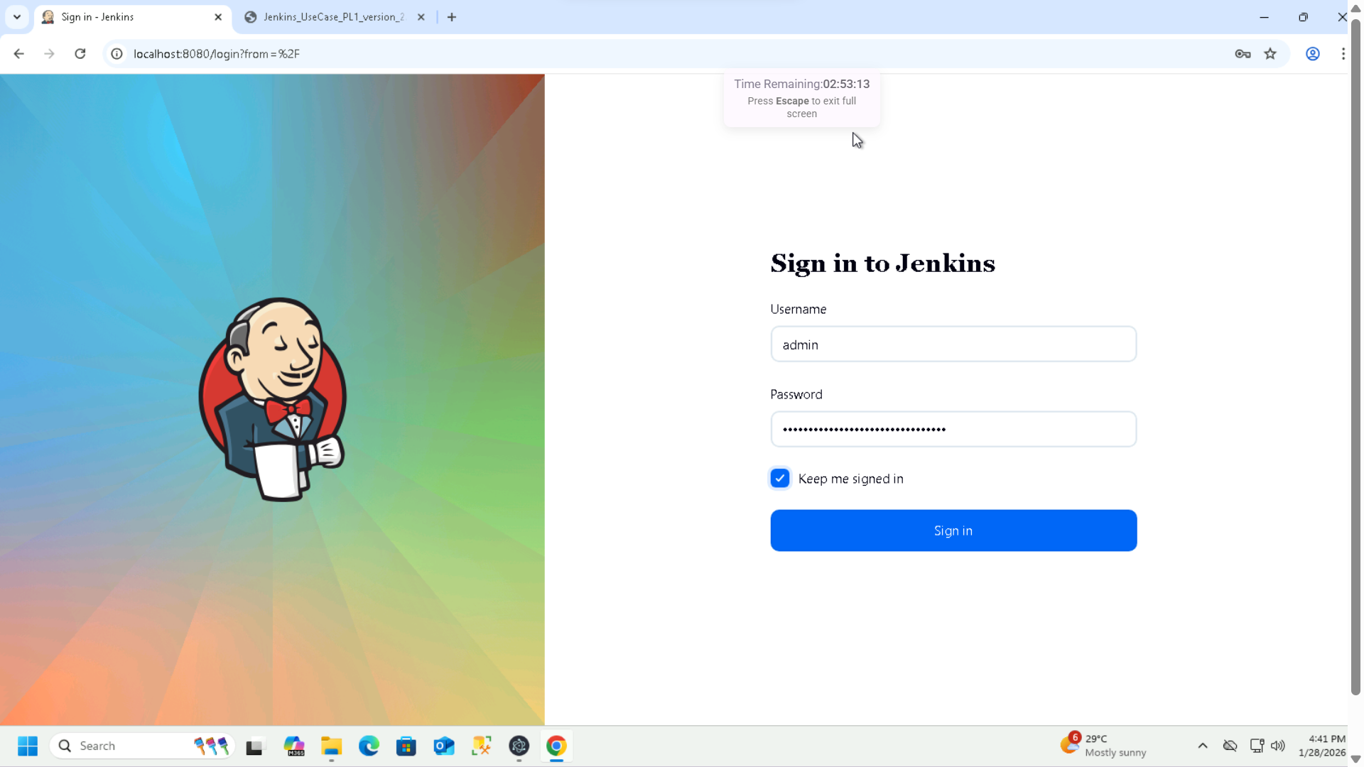

**Step 2: Configure JDK Inside Jenkins**

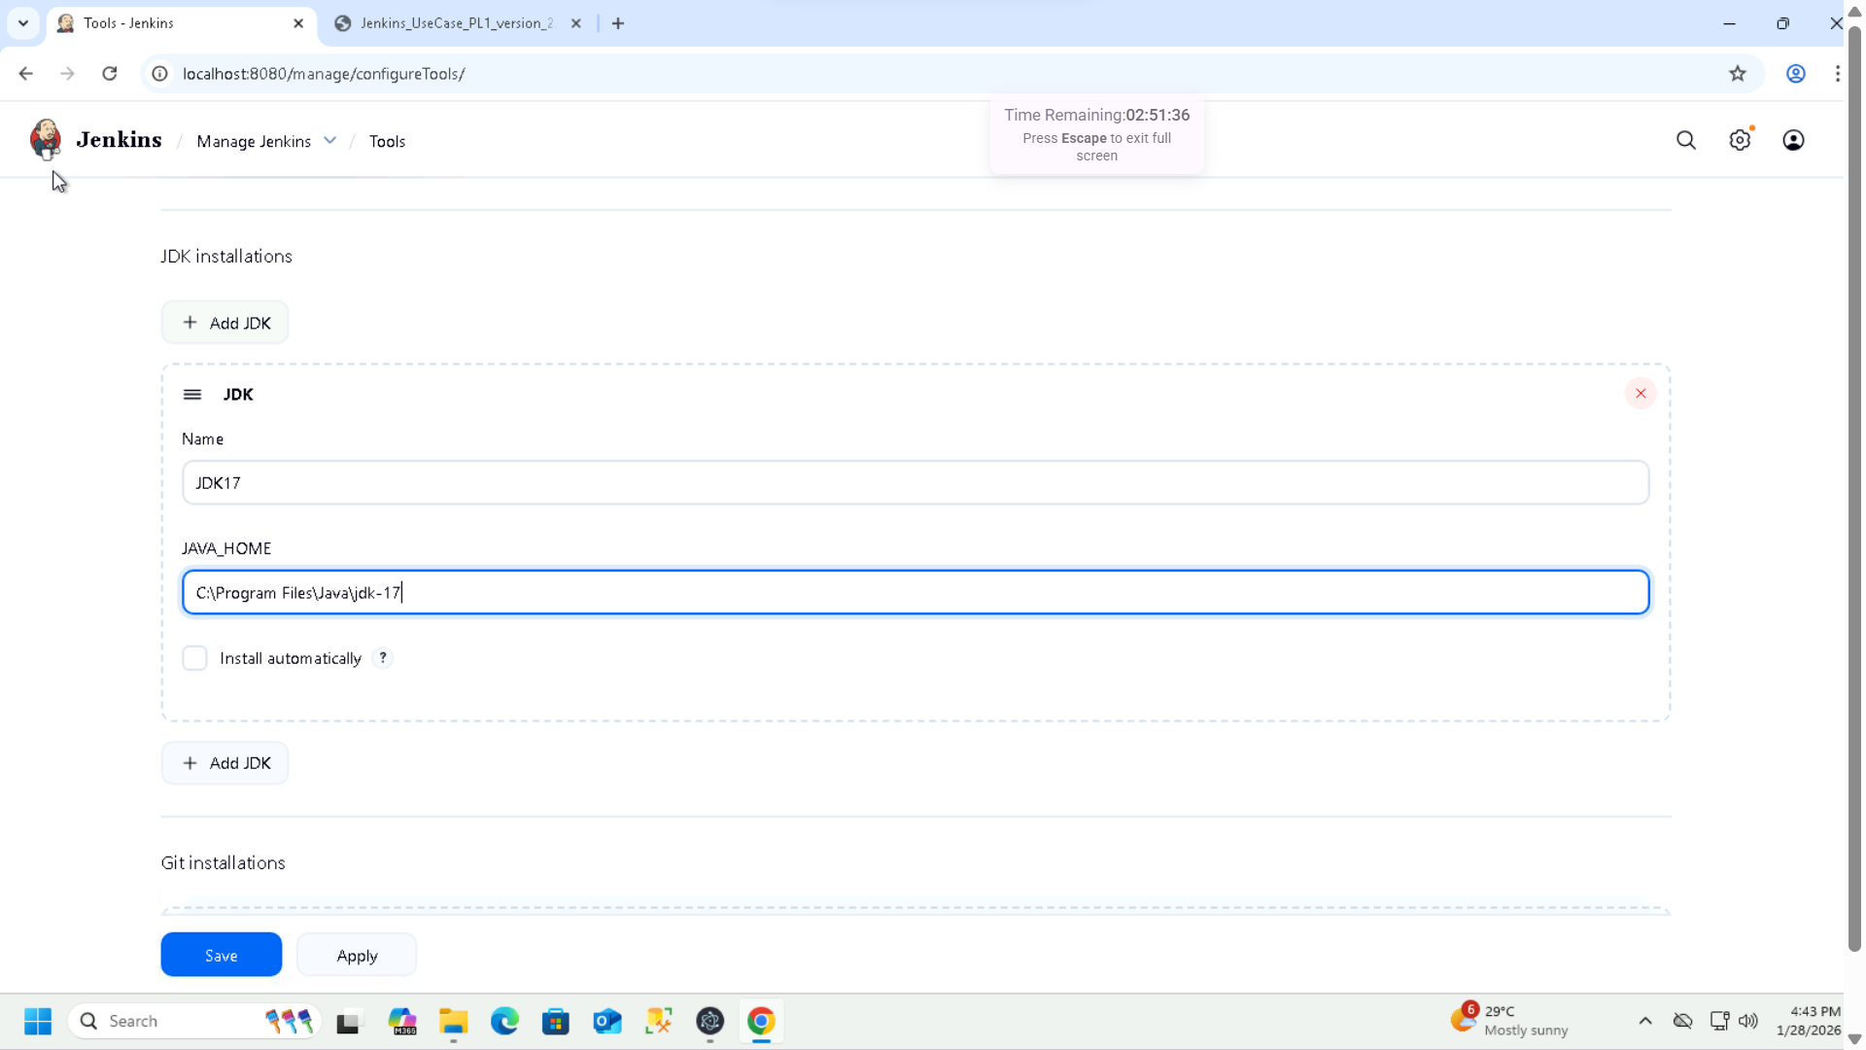

**Step 3: Configure Git in Jenkins**

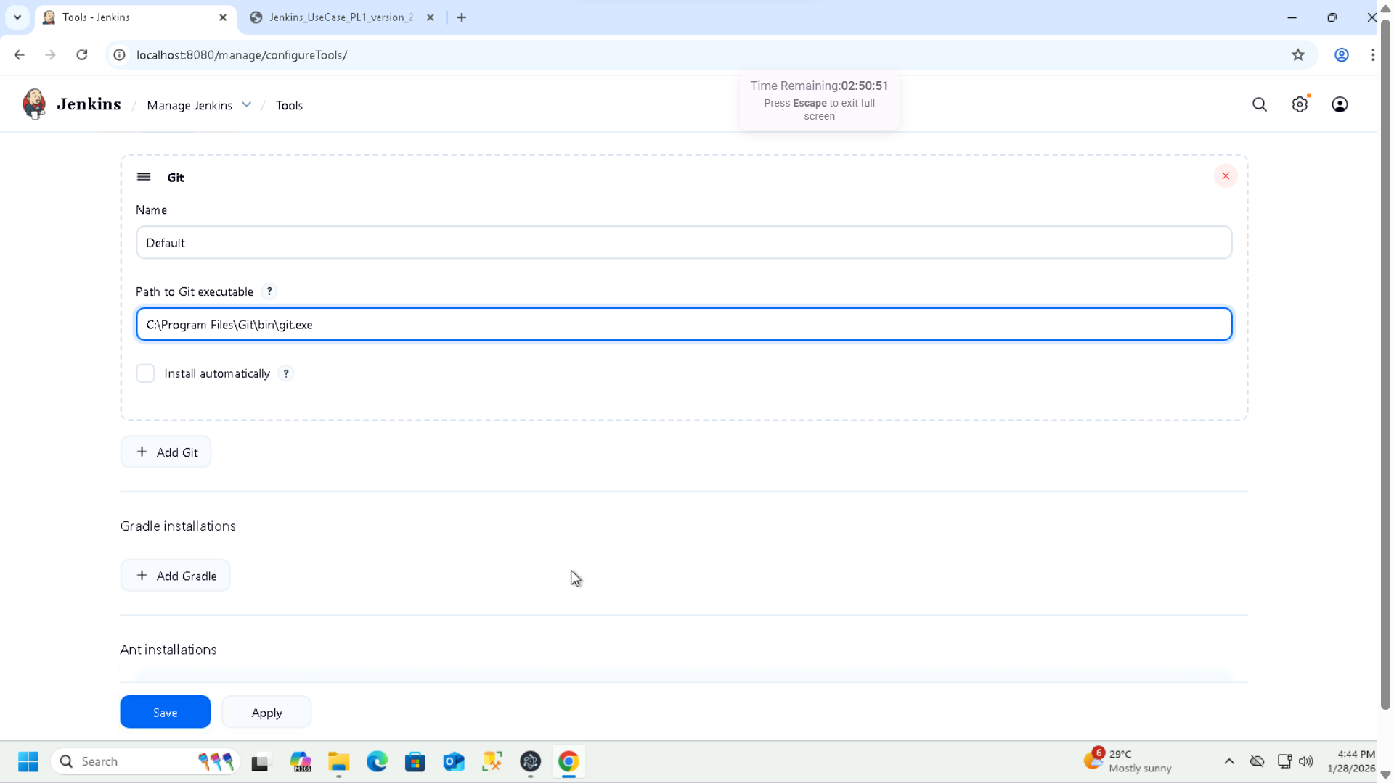

**Step 4: Install and Configure Required Plugins**

1. **Git Plugin**

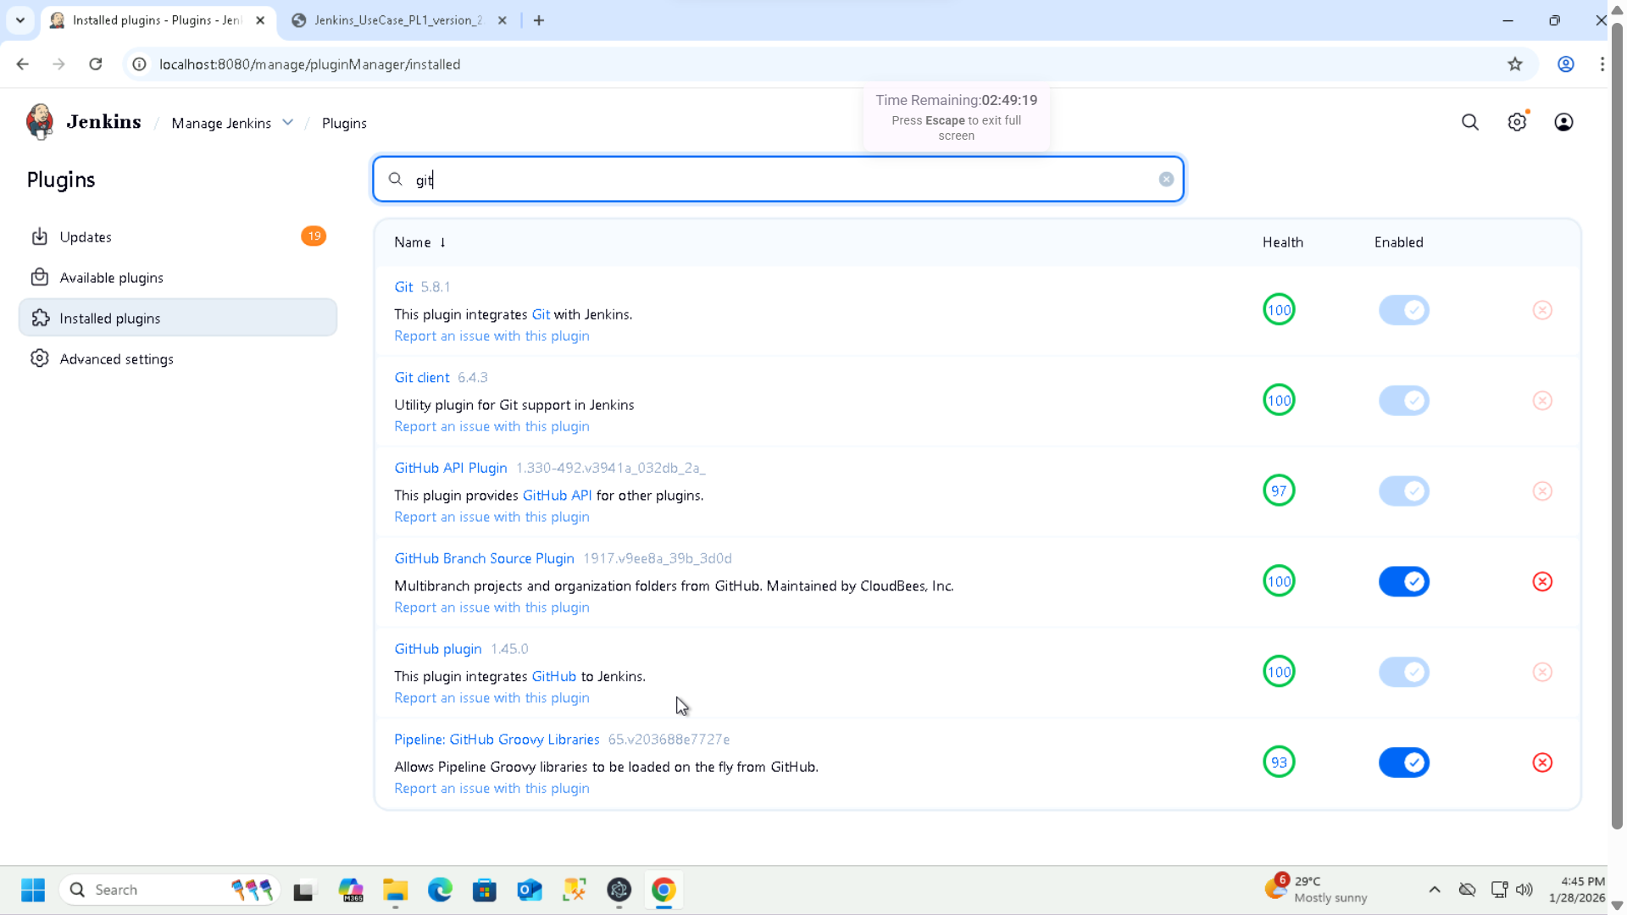

1. **JUnit Plugin**

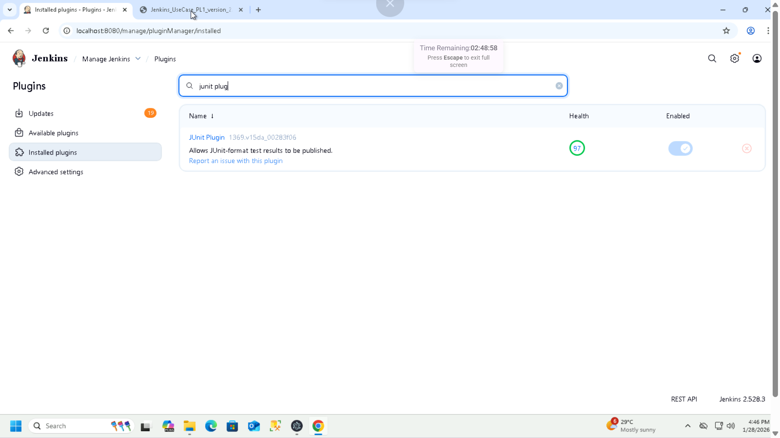

1. **Email Extension Plugin**

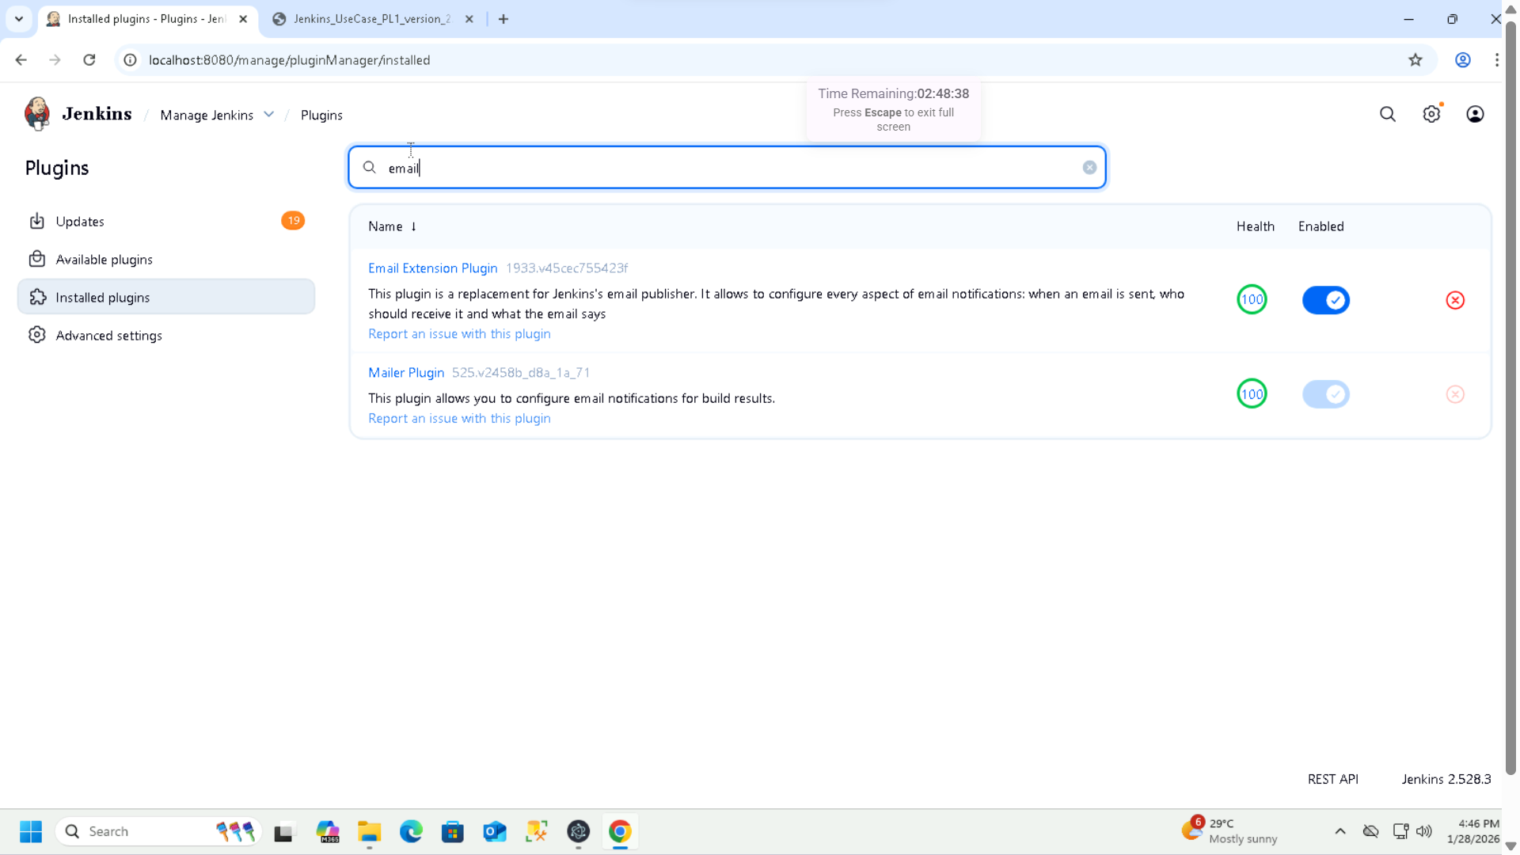

**Email configuration in manage Jenkins**

**Email Notification:**

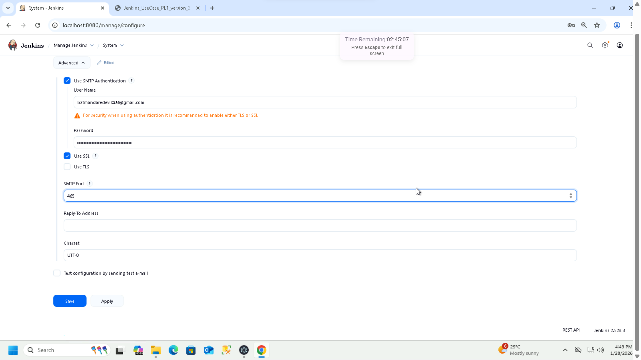

**Extended Email Notification:**

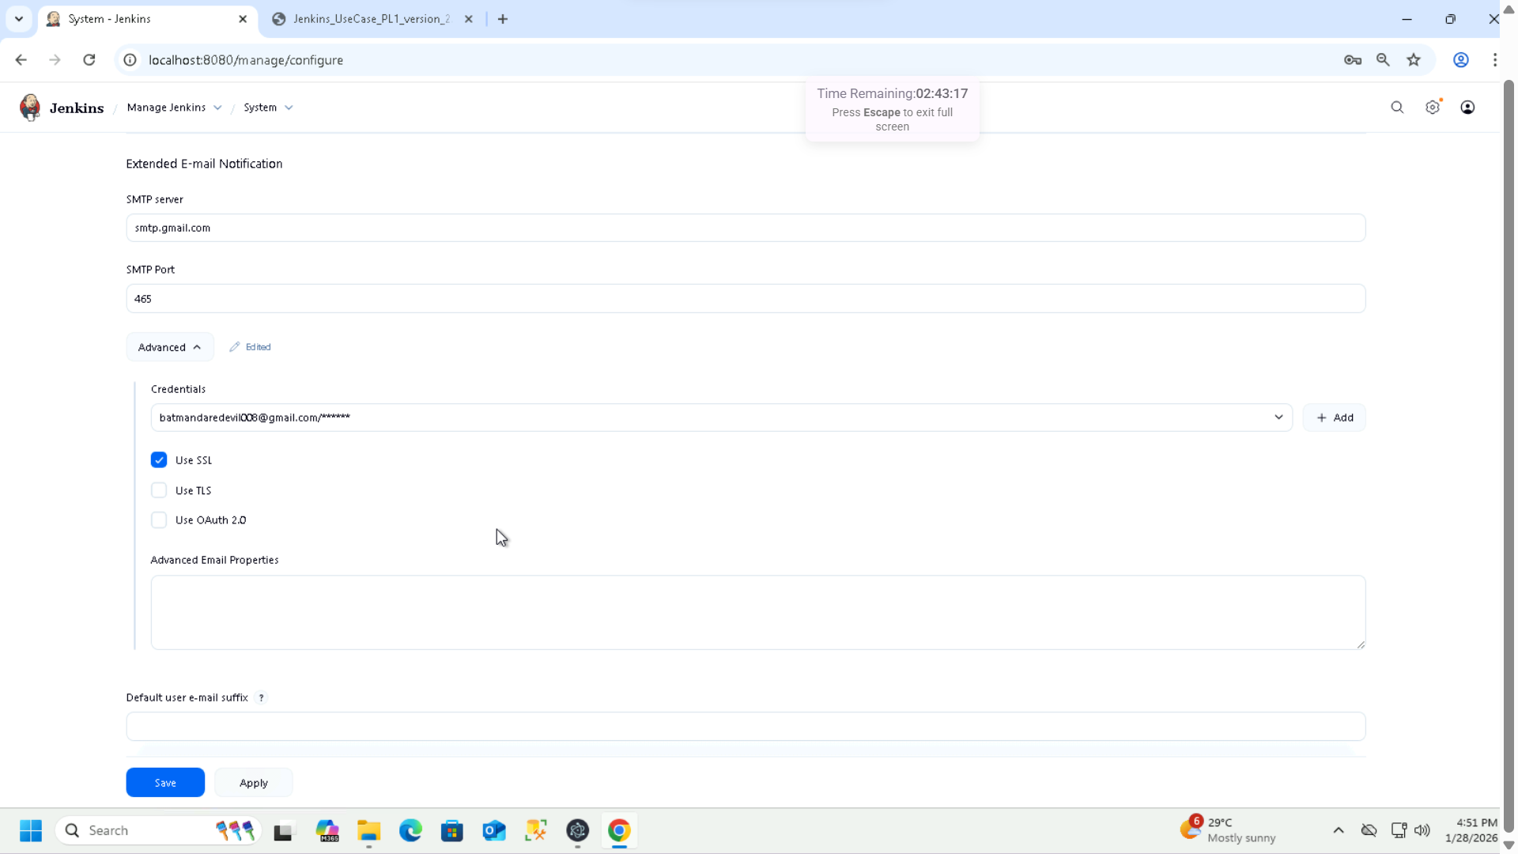

**User Story 2: Create a Basic Freestyle**

**Job 1: Create a freestyle job**

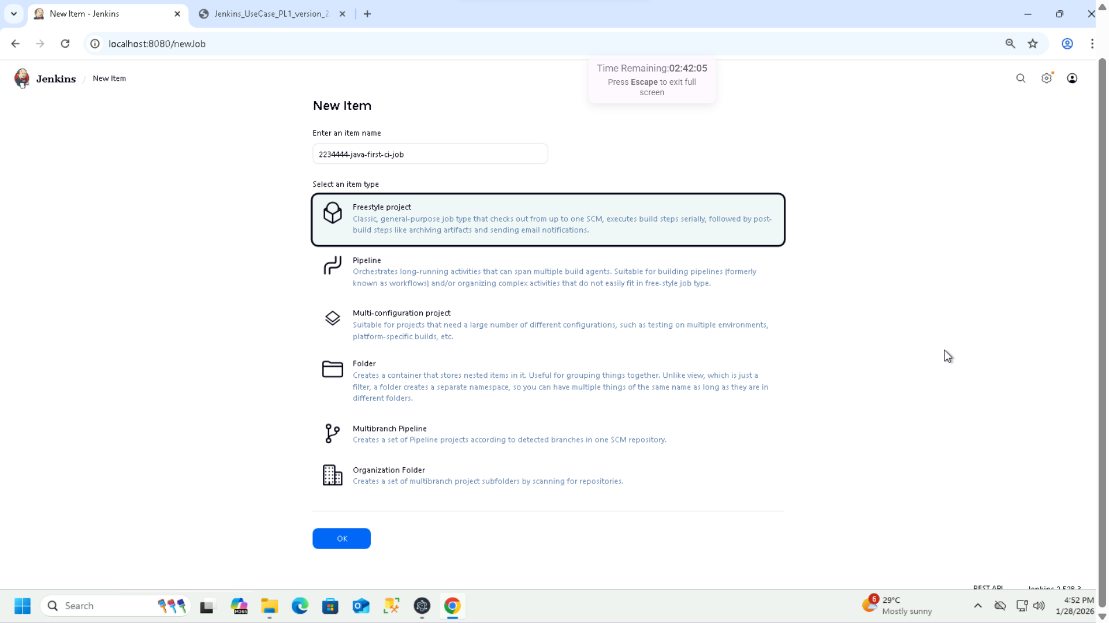

**GitHub Repo URL:** [**https://github.com/expertszen/java-standalone-application.git**](https://github.com/expertszen/java-standalone-application.git)

**Branch: Main**

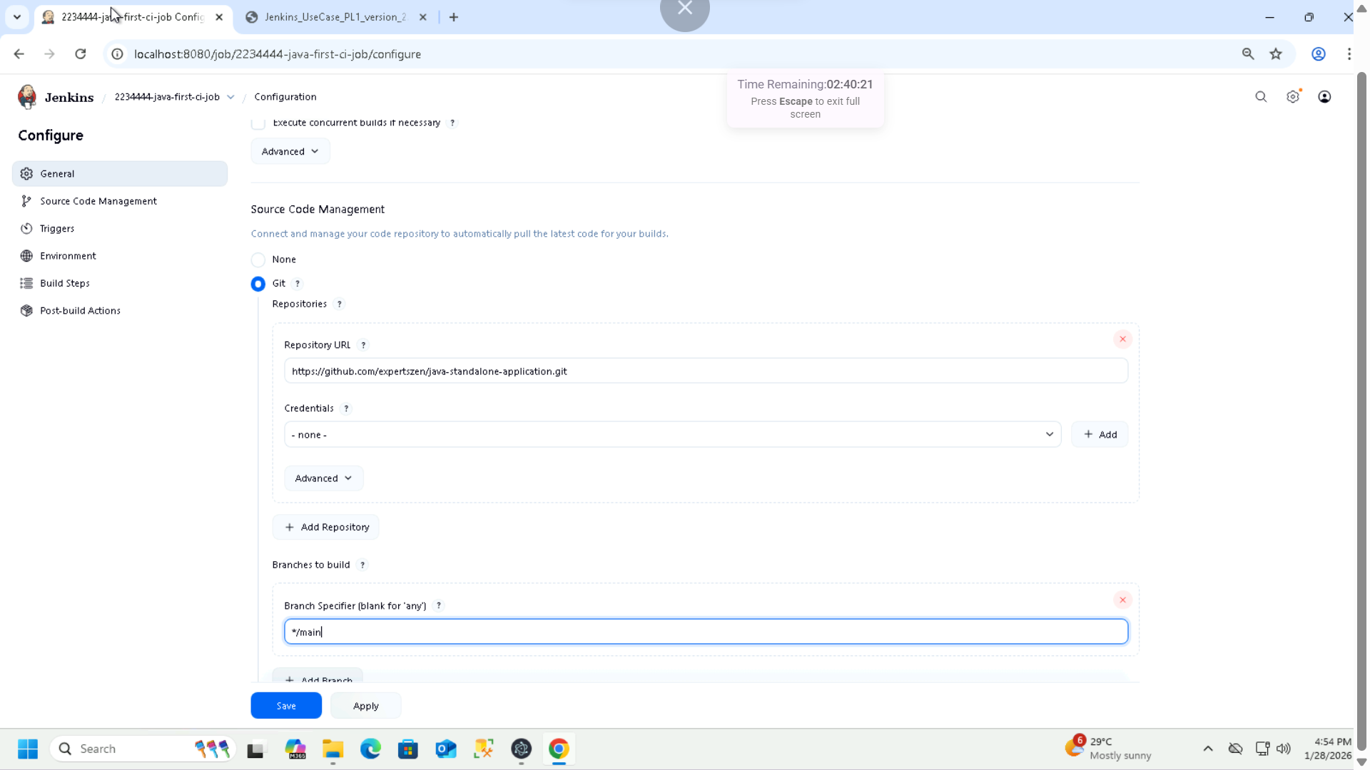

**2: Build steps**

**a. Install Maven Dependencies: Execute Windows batch command: mvn clean install -DskipTests**

**b. Build the java code: Execute Windows batch command: mvn compile**

**c. Test the existing junit test case Execute Windows batch command: mvn test**

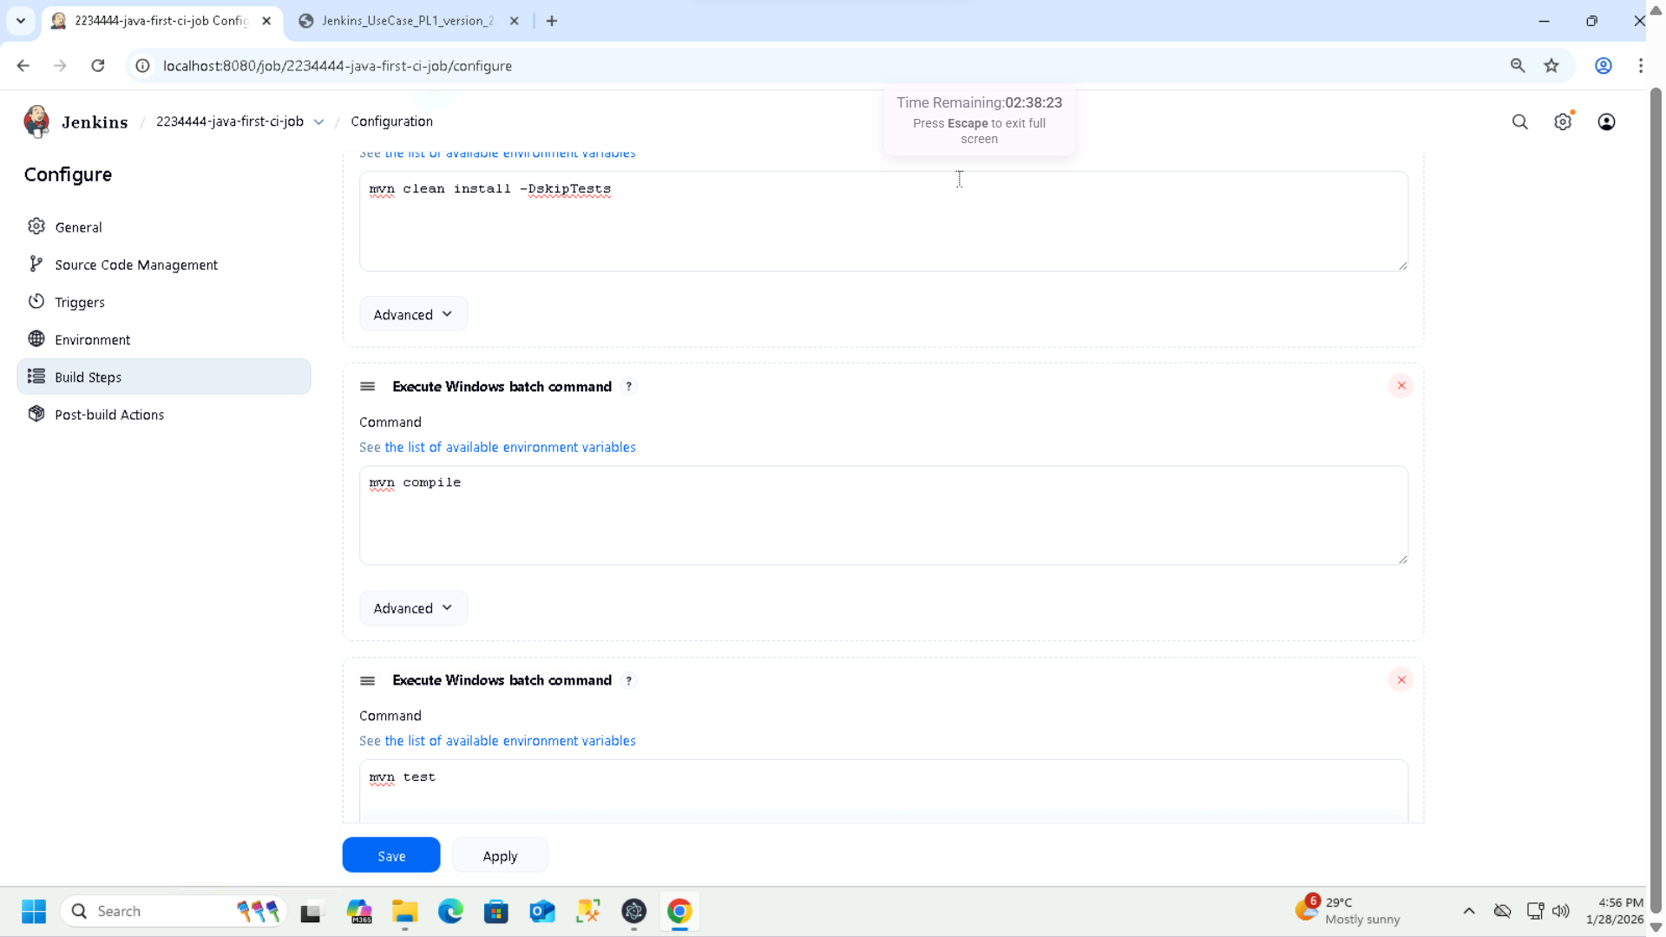

**Post Build Action:**

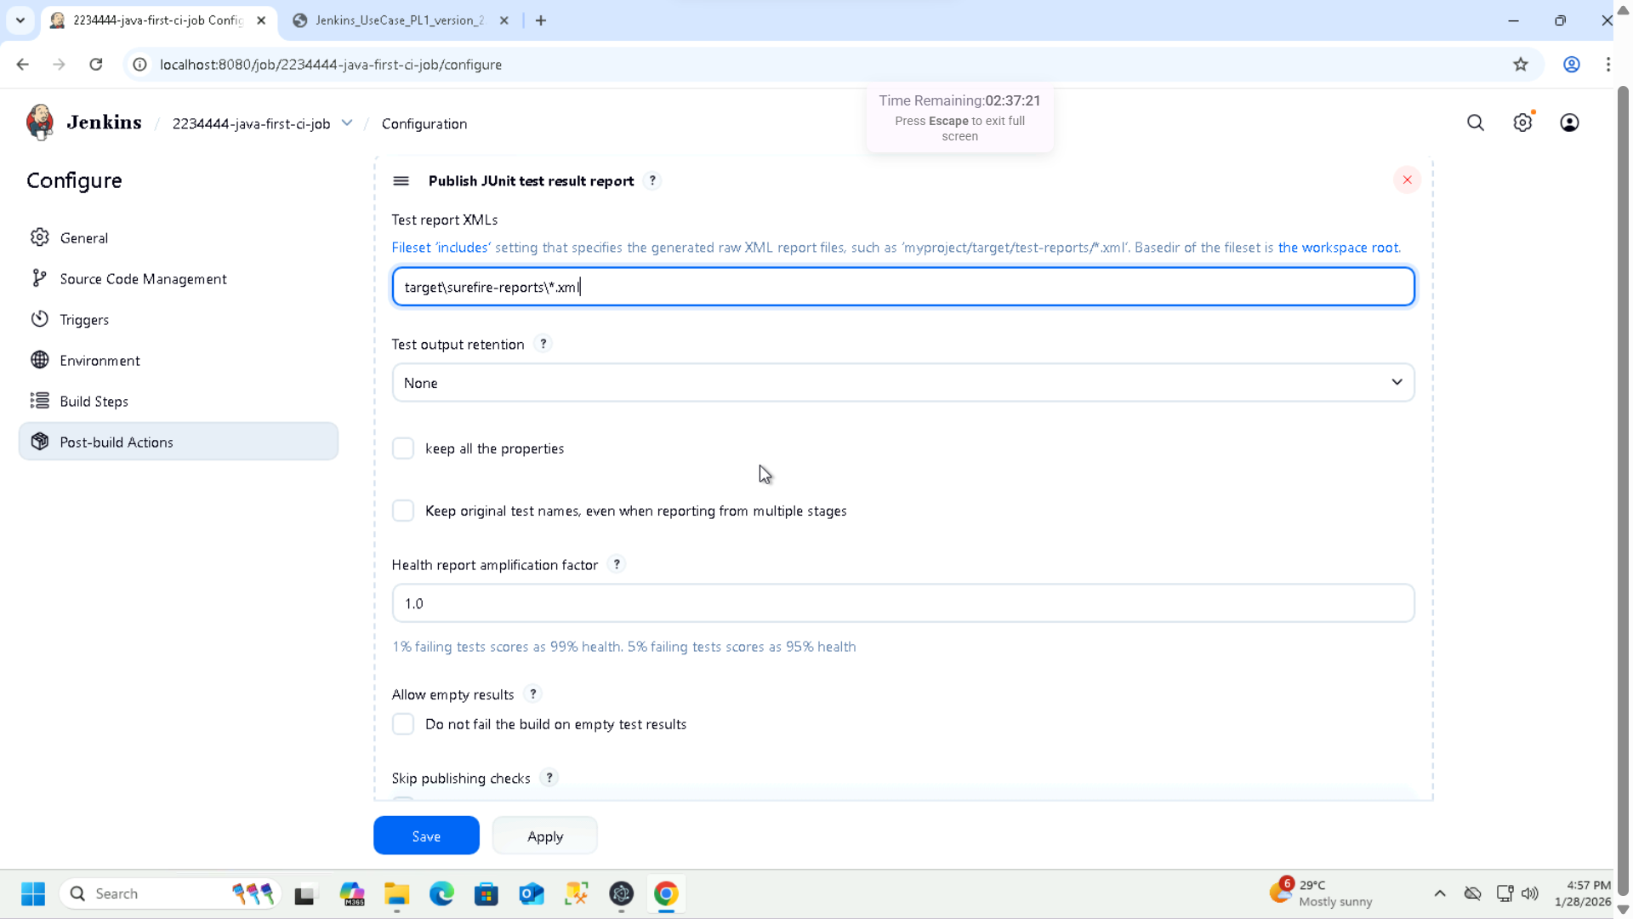

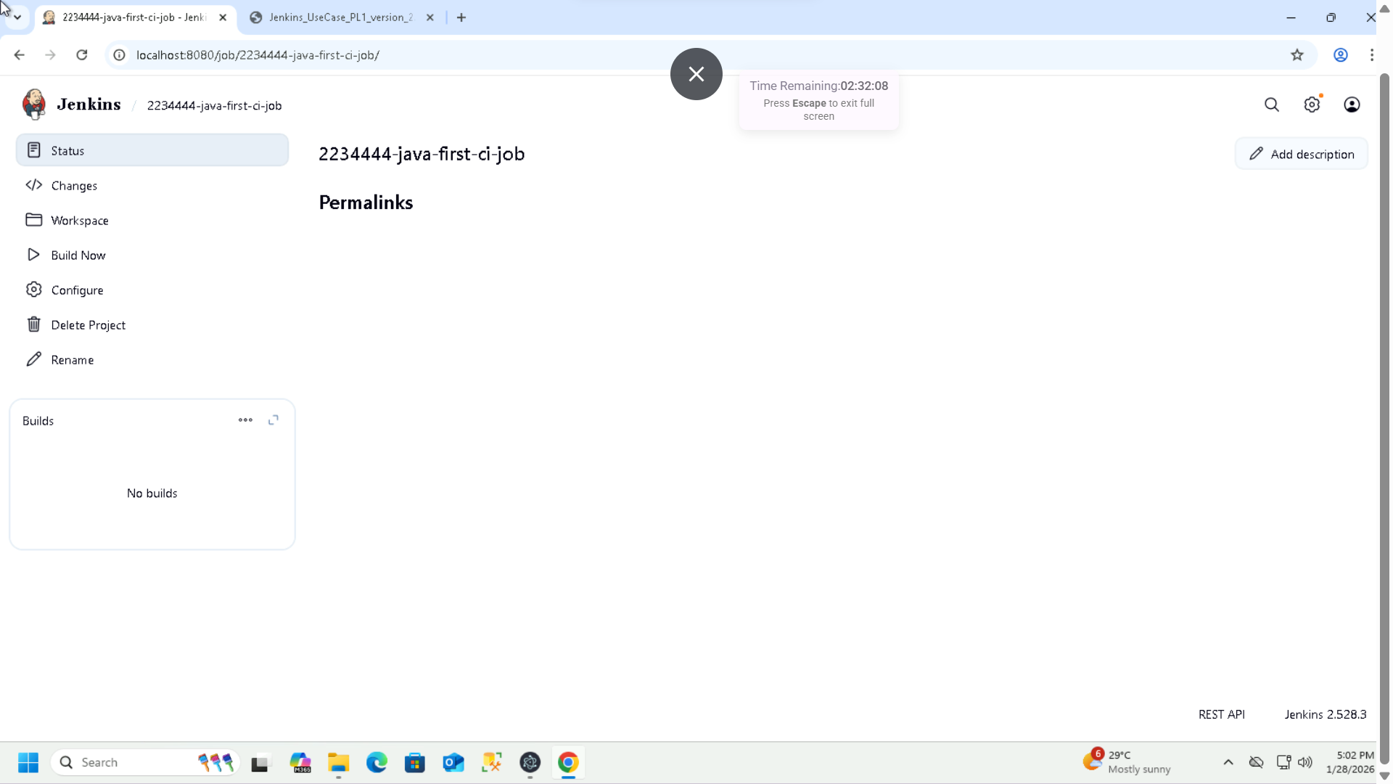

**3: Run the job ‘Build Now’**

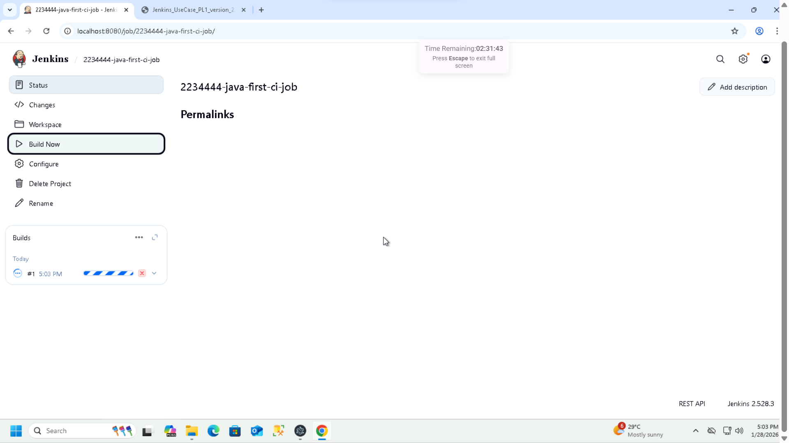

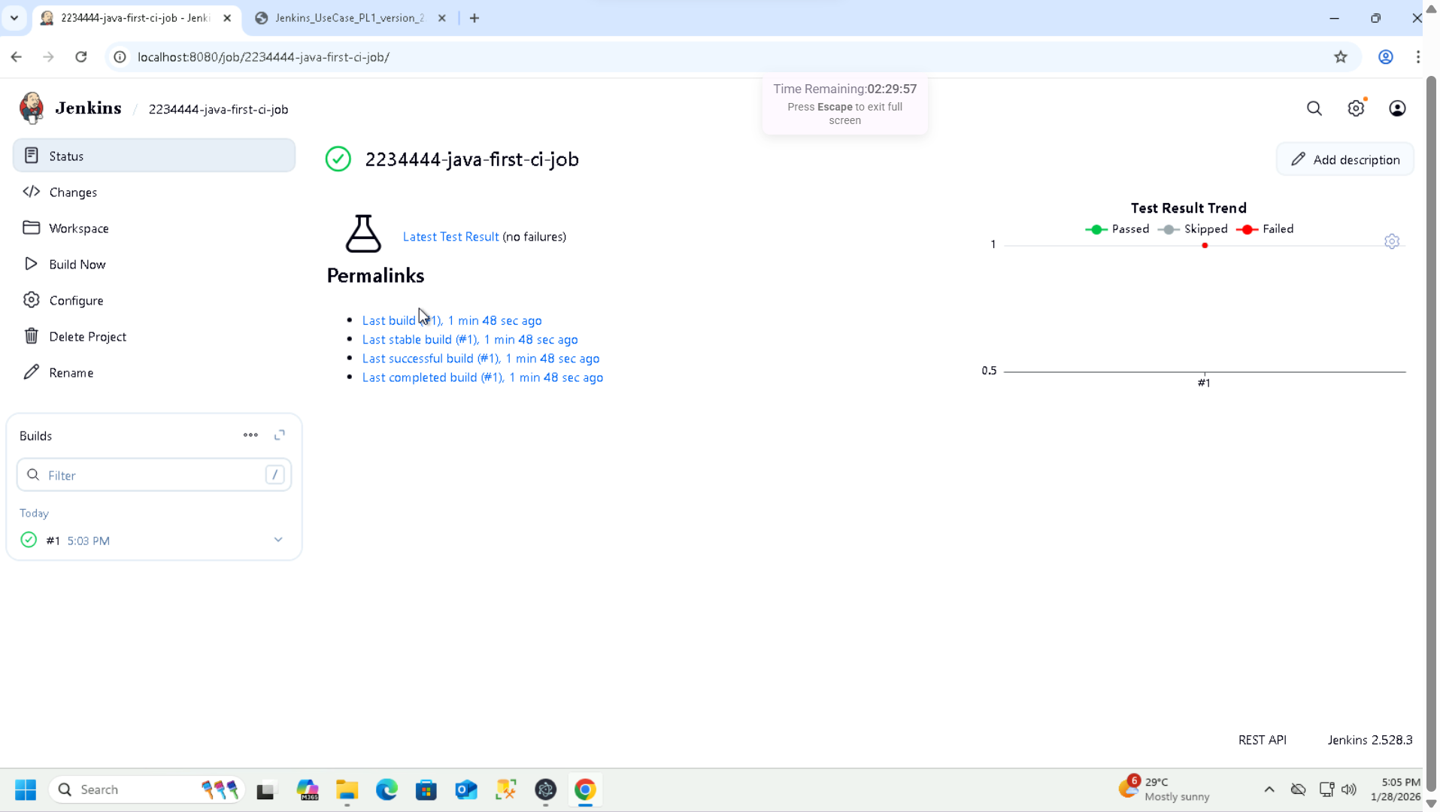

**Console Log:**

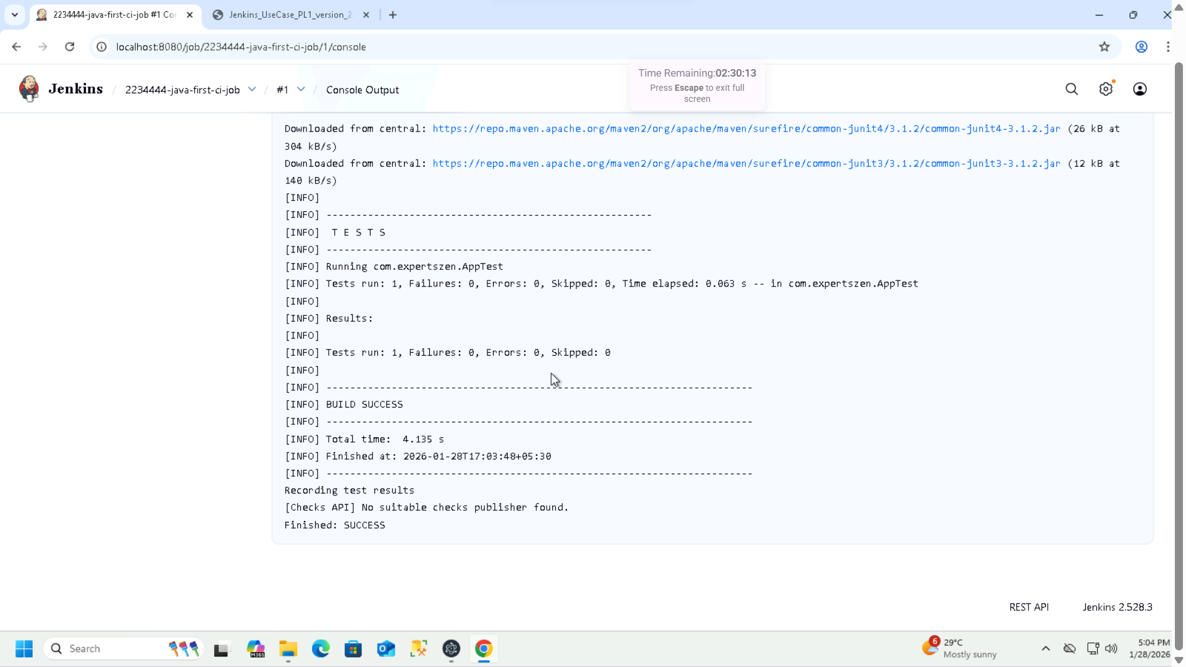

**User Story 3: Execute the CI Pipeline with the schedule Tigger the job to run at 9:00 AM IST on every Monday using cron expression:**

**Build periodically- Schedule: 0 9 * * 1**

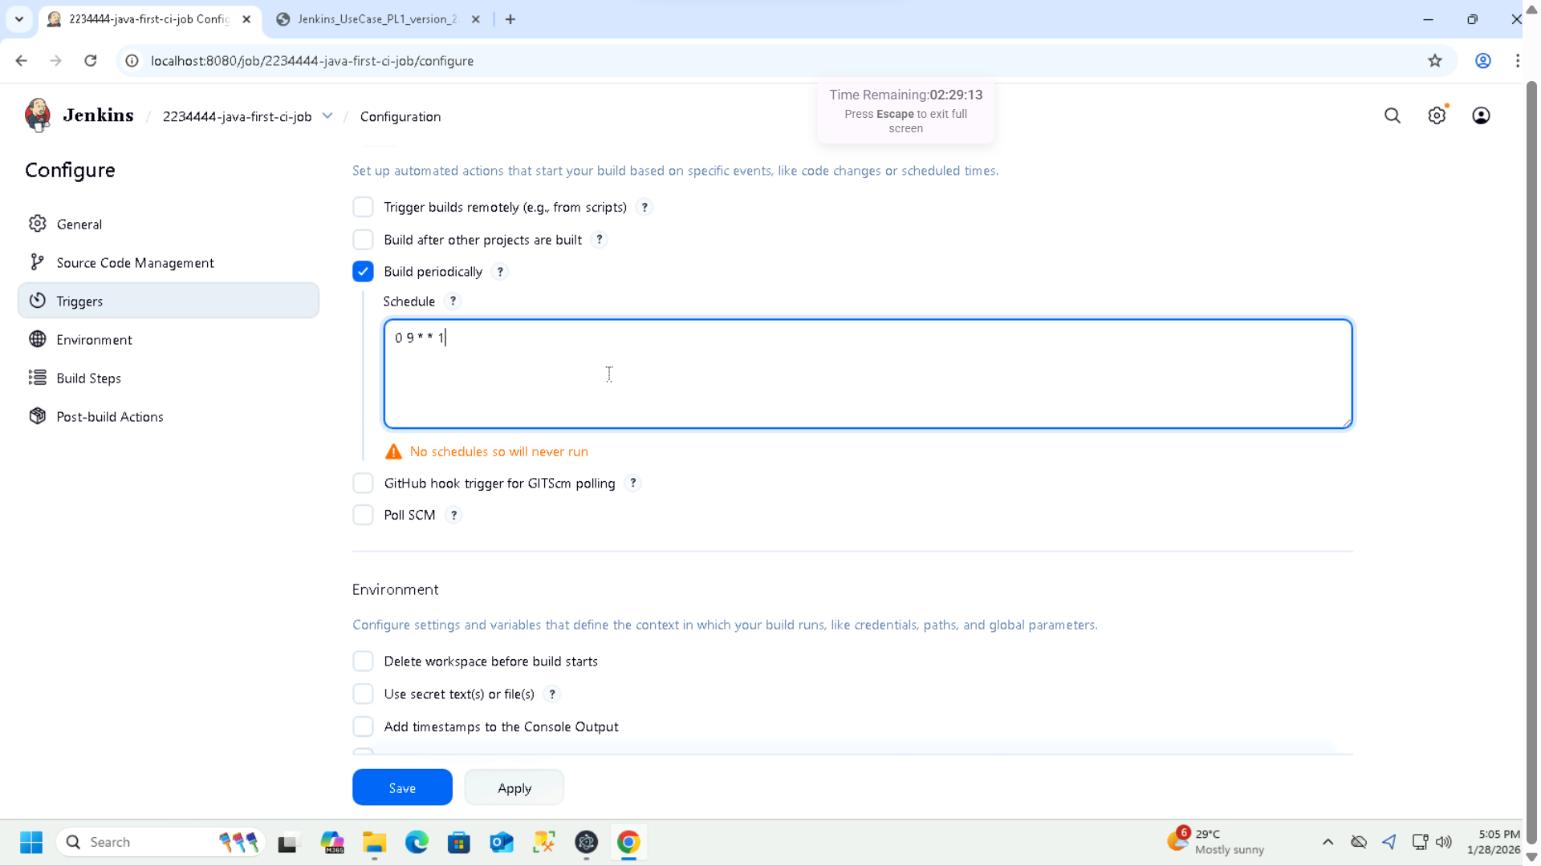

**Note: Changing the schedule to run at 05:09PM every Wednesday to capture the result:**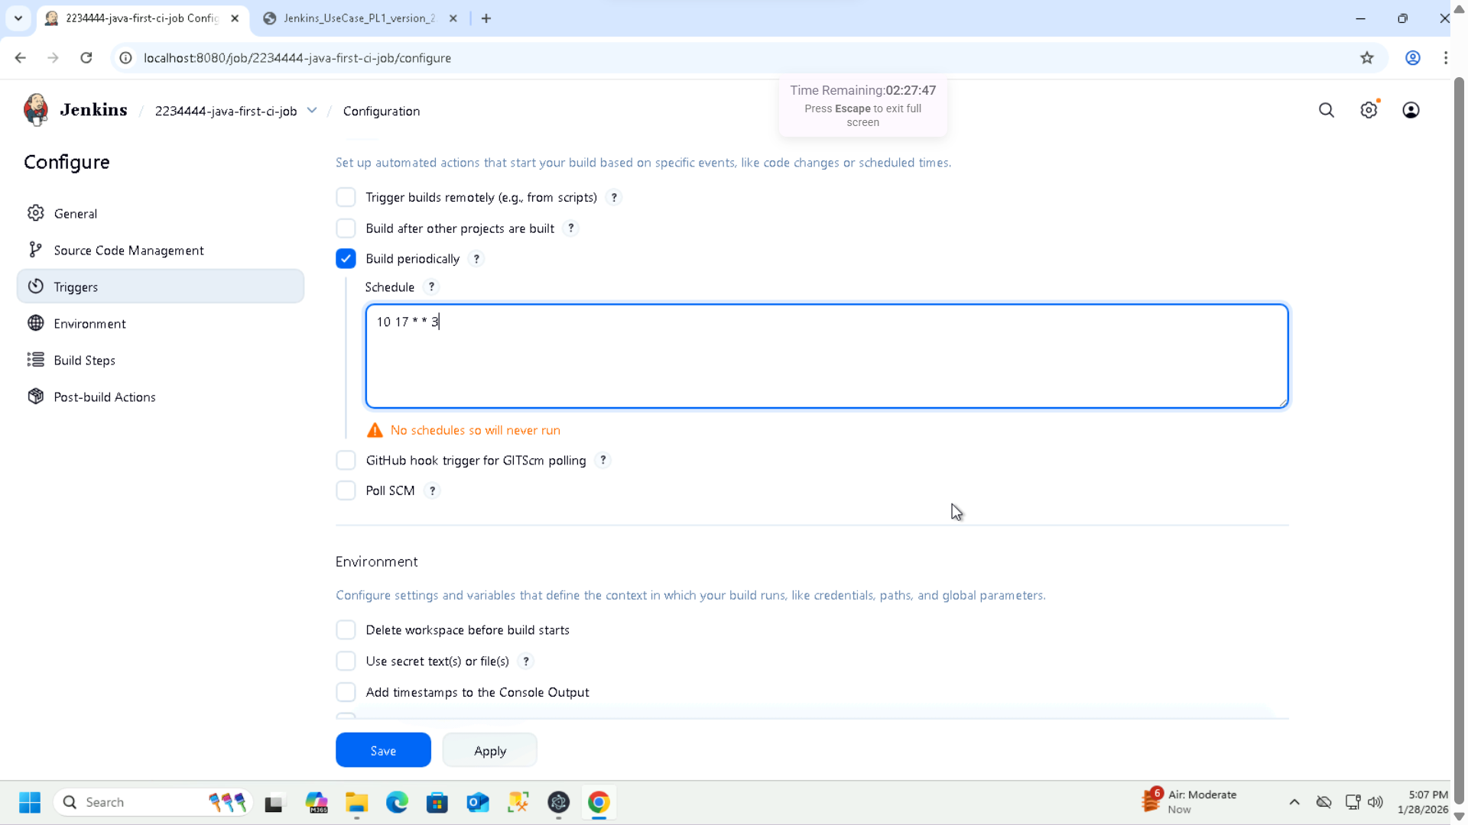

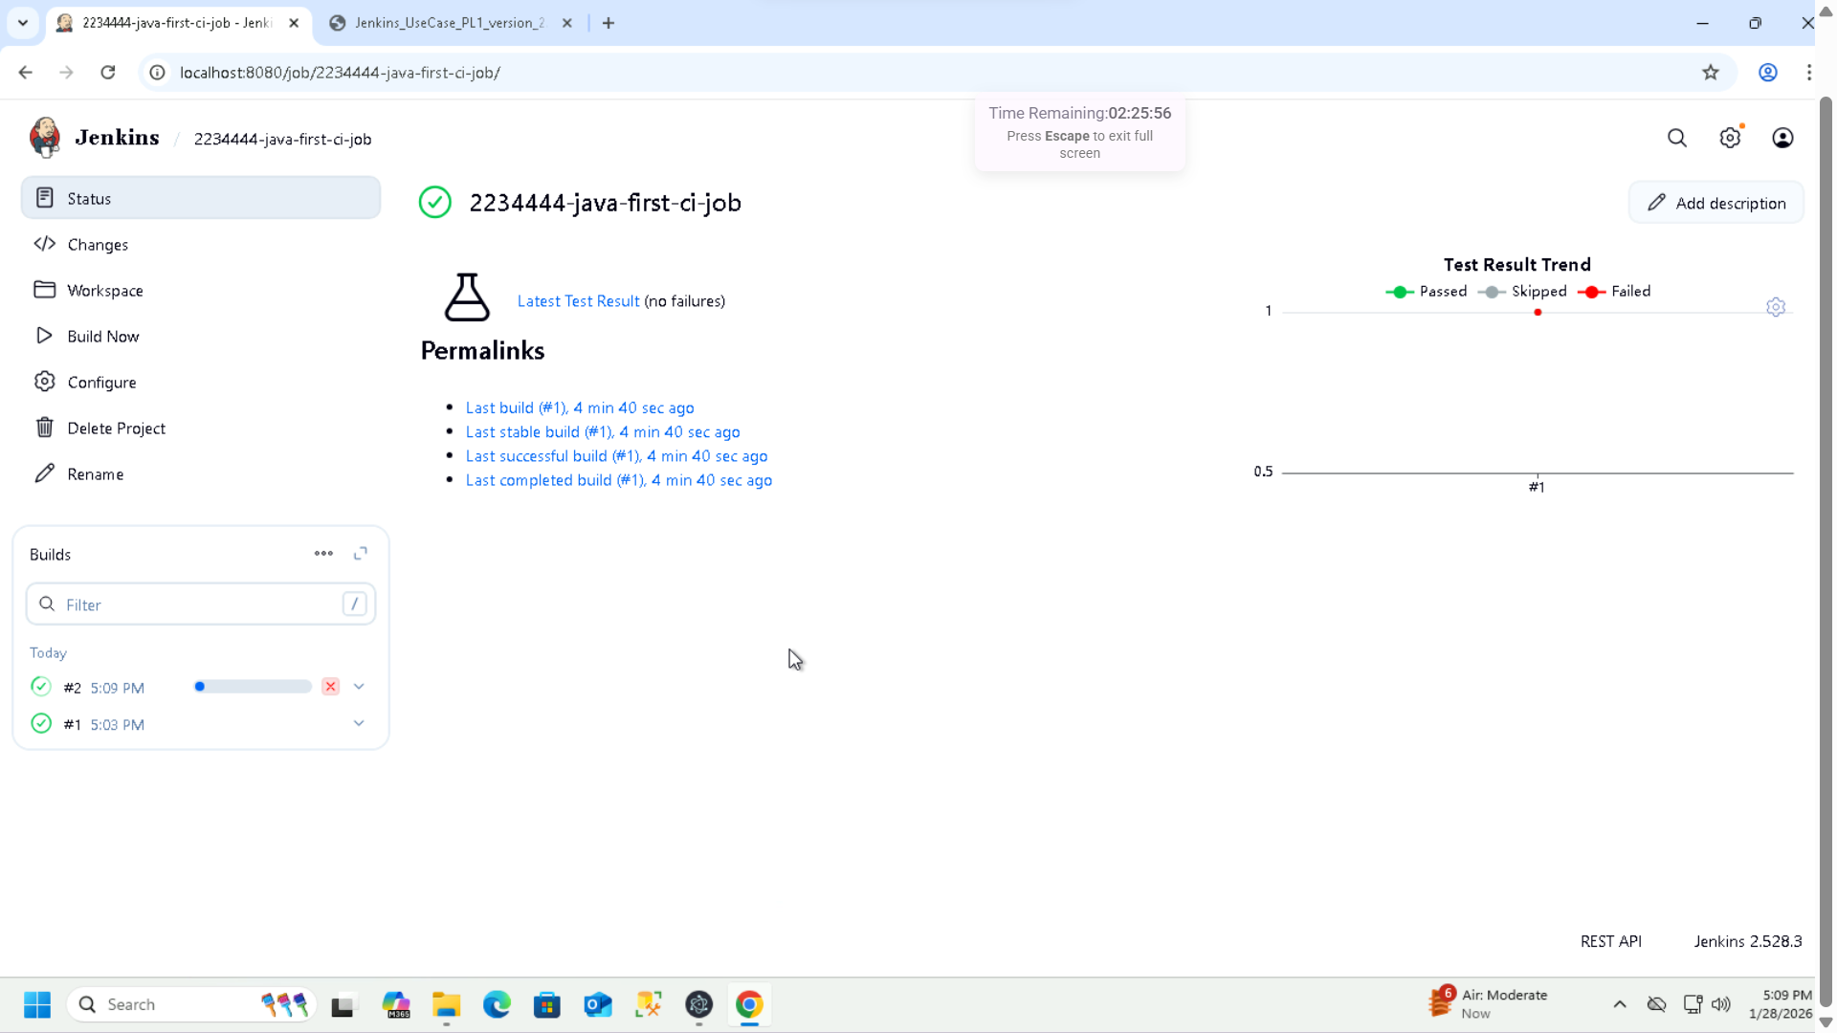

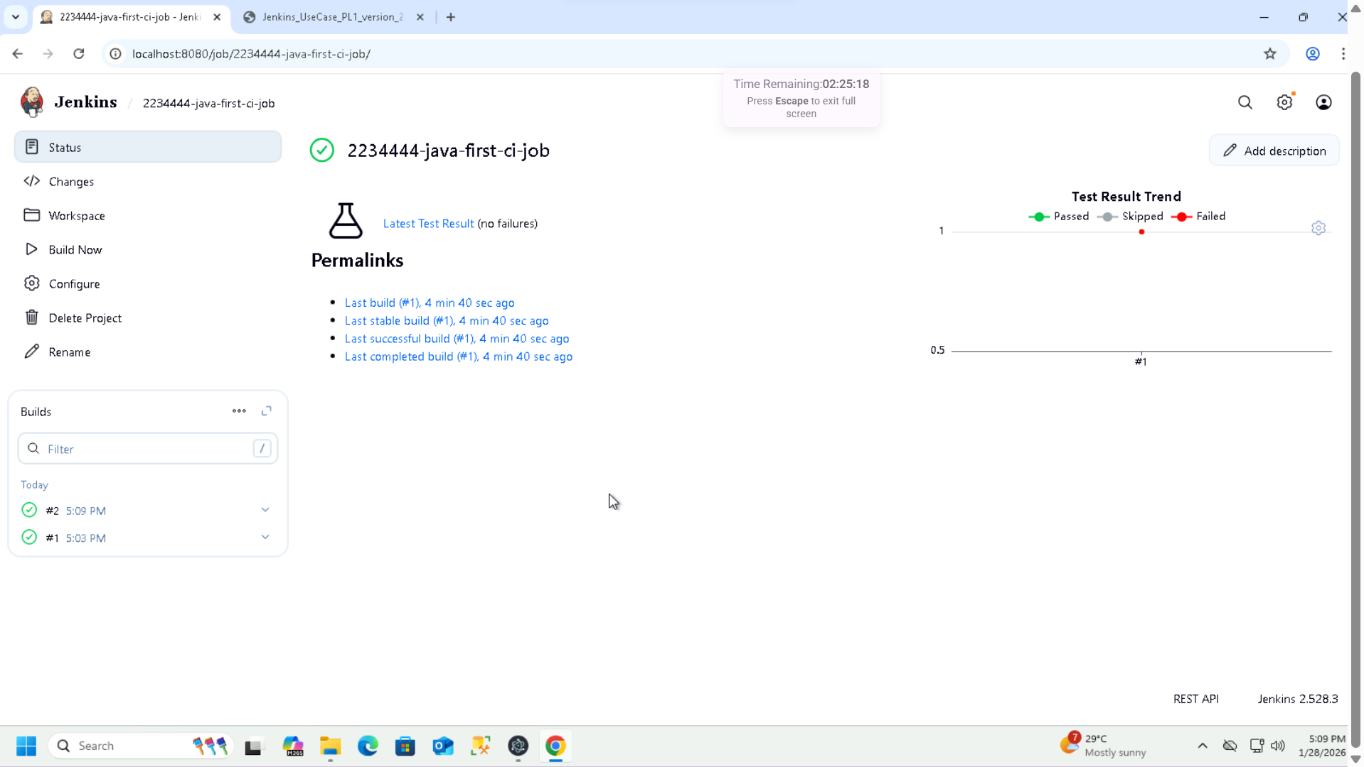

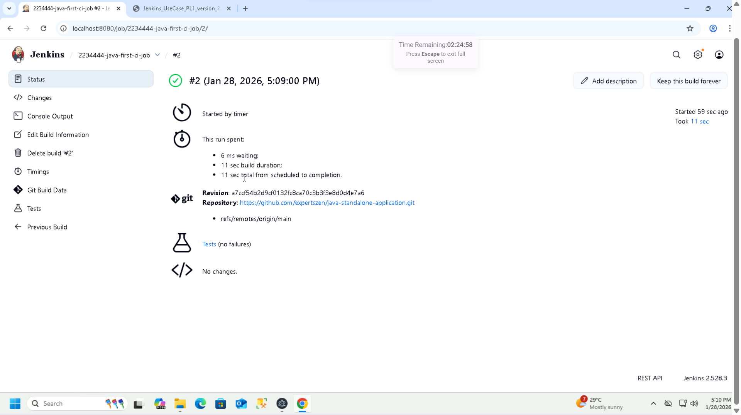

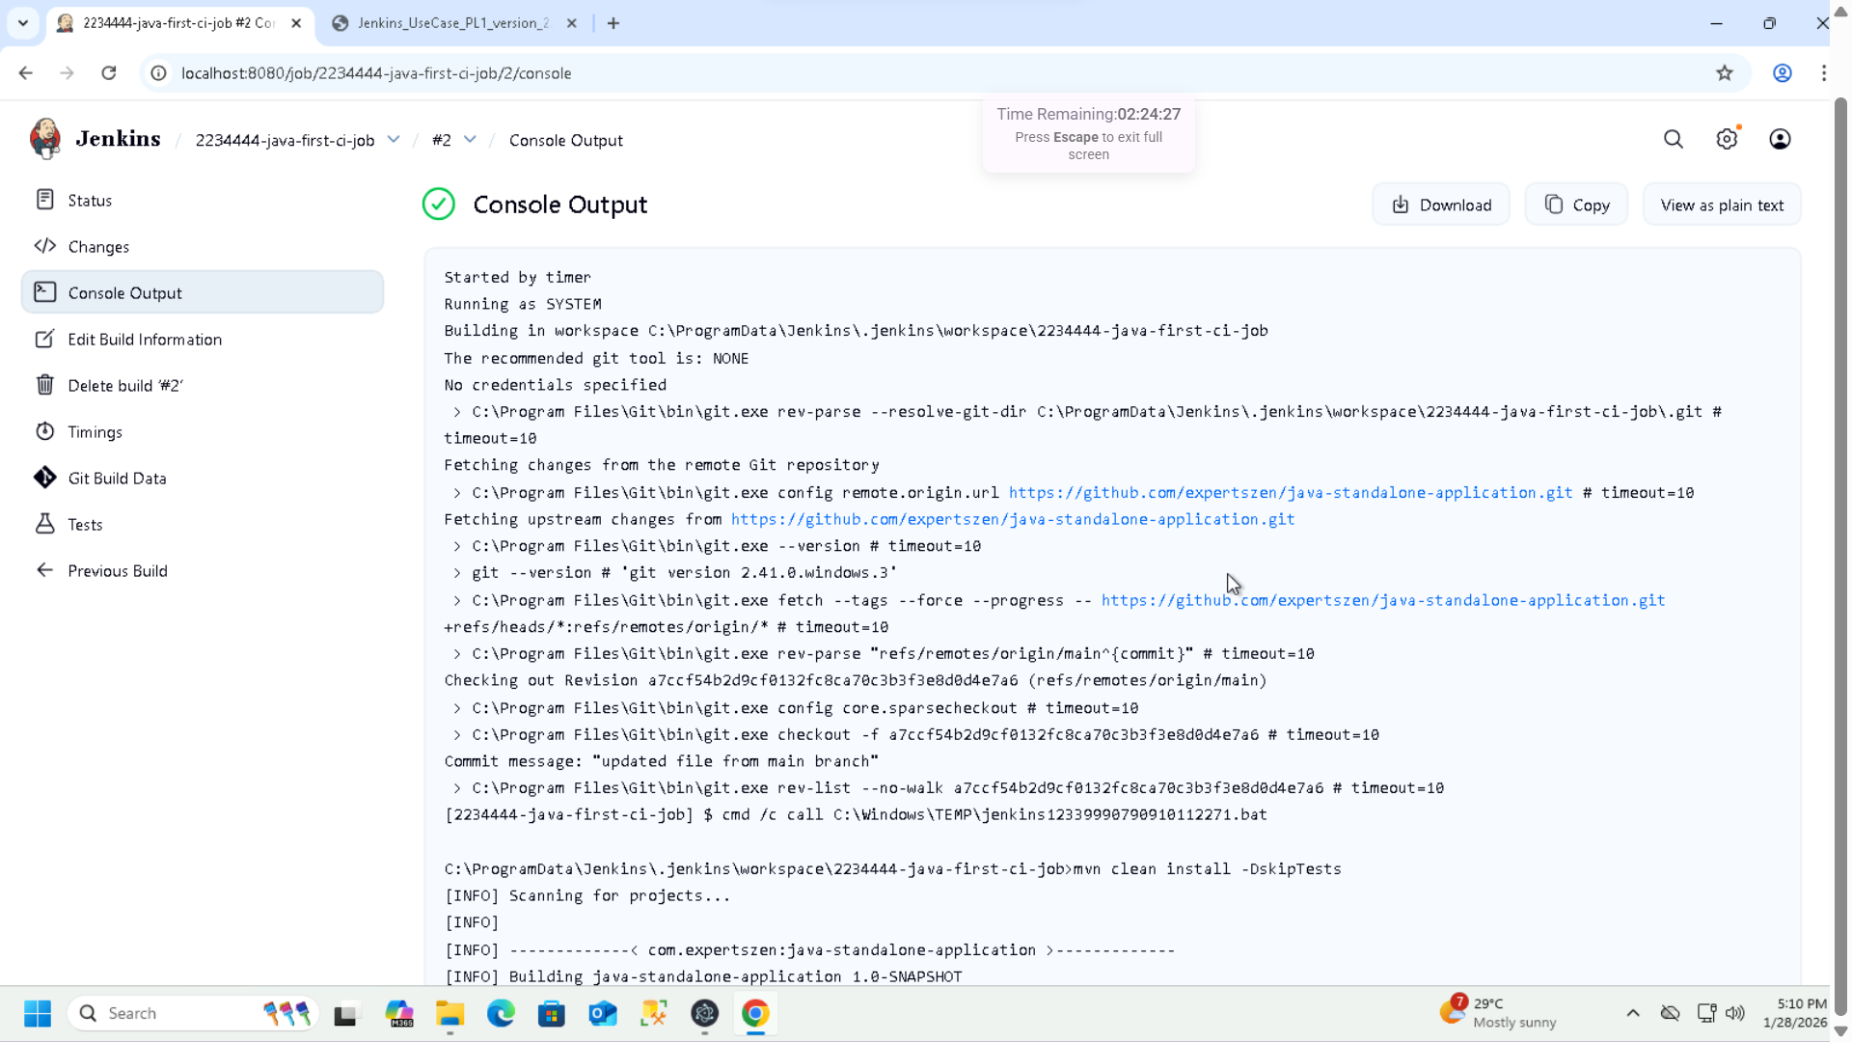

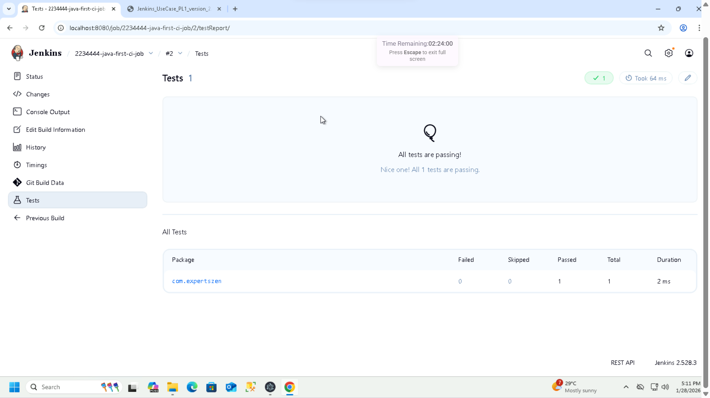

**User Story 4: Use Plugin for Job Enhancement**

**1: Post-build Actions: Editable Email Notification**

**2: Setup Always tiggers in Post build actions**

**3: SMTP configuration for email**

**4: Email Recipient setup**

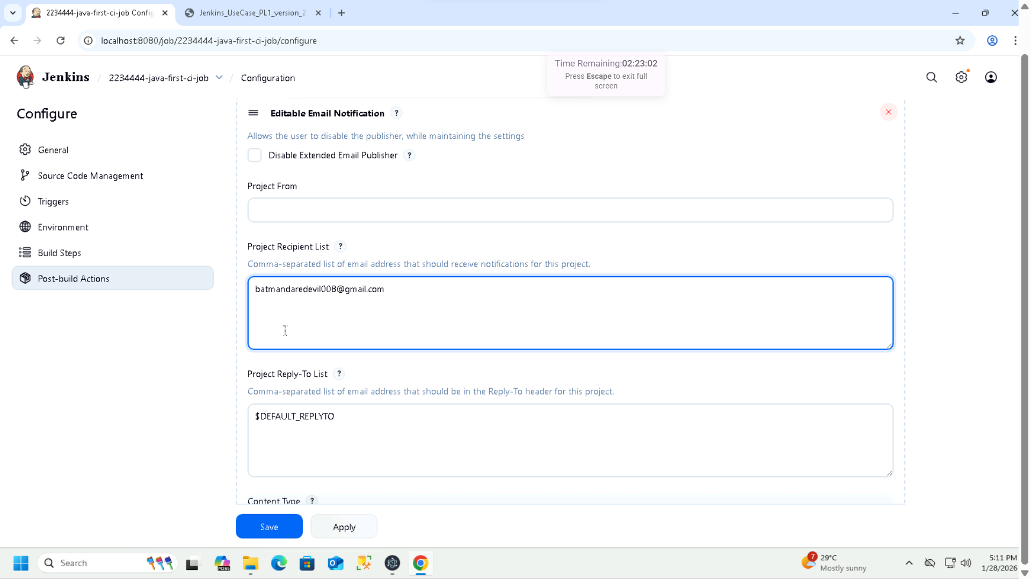

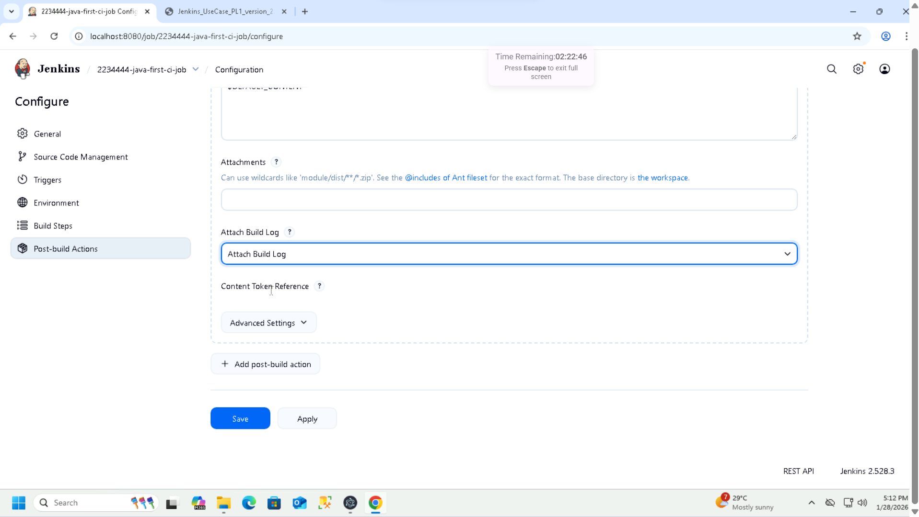

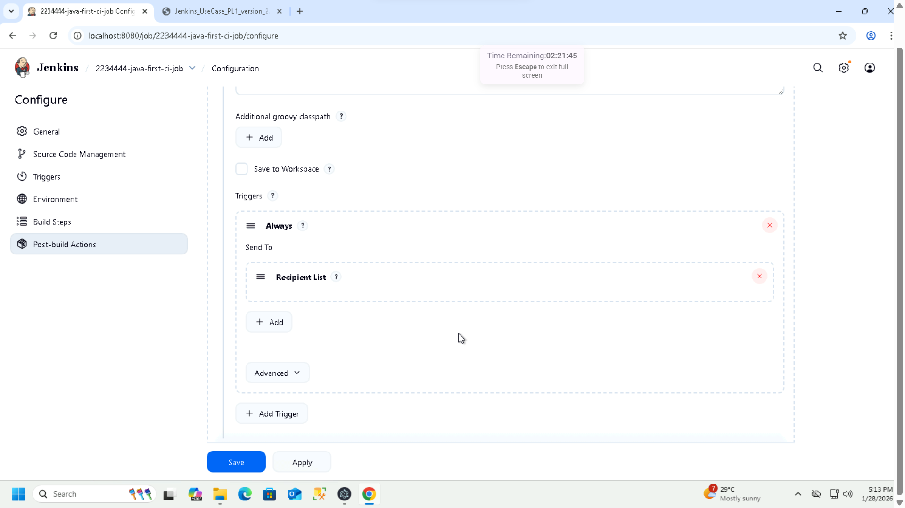

**Note: Changing the schedule to run at 05:15 PM every Wednesday to capture the result**

